Week 1 Assignment – SRS Document Development and GitHub Paper
Maria Reyes
The University of Arizona Global Campus
CST 499 Capstone for Computer Software Technology
Instructor Charmelia Butler
September 26, 2023

Software Requirements Specification
for
<Enrollment System>
Version 1.0 approved
Prepared by <Maria Reyes>
<The University of Arizona Global Campus>
<September 26, 2023>
Table of Contents
Table of Contents ii
1. Introduction 1
1.1 Purpose 1
1.3 Intended Audience and Reading Suggestions 1
1.4 Product Scope 2
1.5 References 2
2. Overall Description 3
2.1 Product Perspective 3
2.2 Product Functions 3
2.3 User Classes and Characteristics 3,4
2.4 Operating Environment 4
2.5 Design and Implementation Constraints 4,5
2.6 User Documentation 5
2.7 Assumptions and Dependencies 5
3. External Interface Requirements 6
3.1 User Interfaces 6
3.2 Hardware Interfaces 6
3.3 Software Interfaces 6
3.4 Communications Interfaces 7
4. System Features 7-9
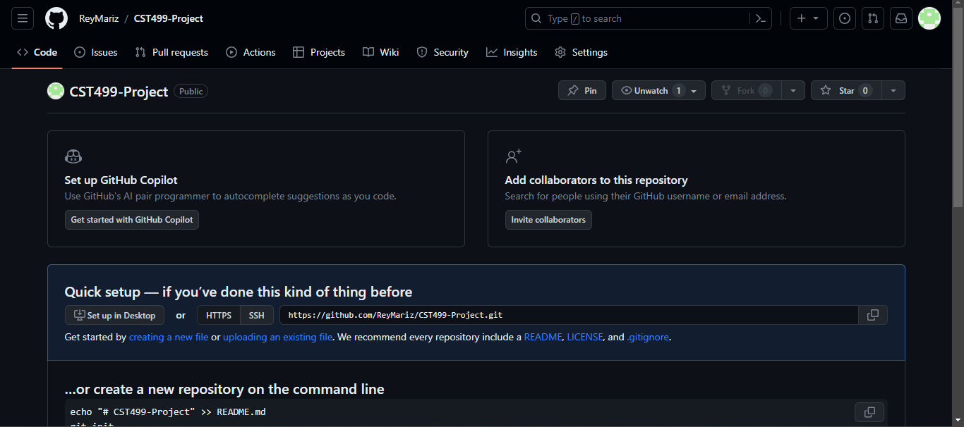
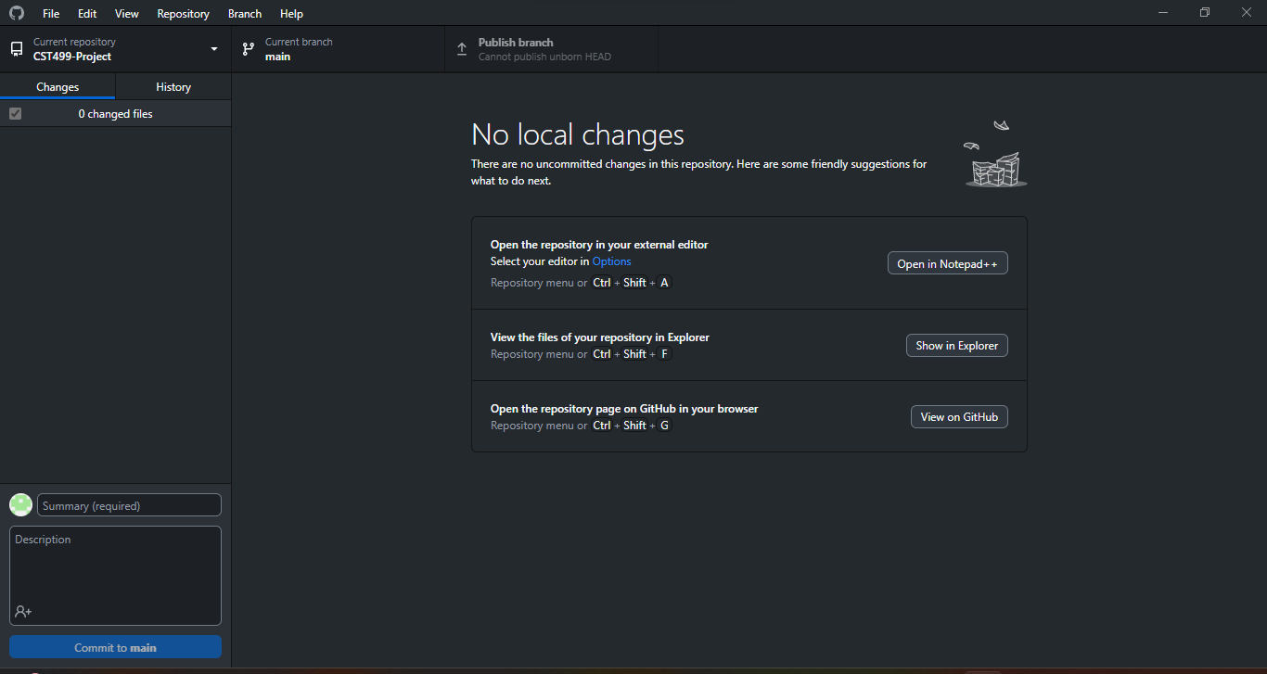
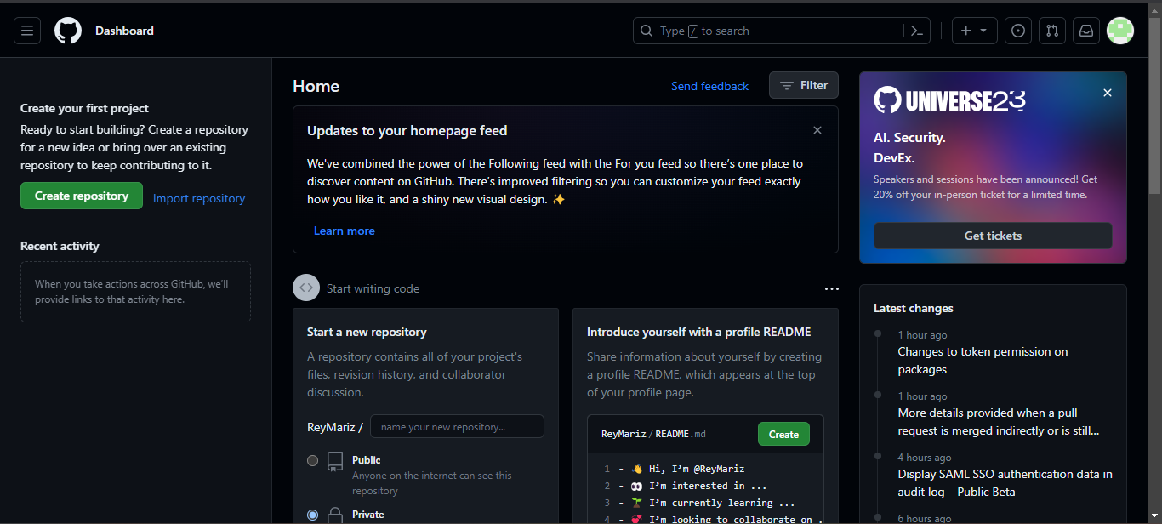

Introduction

Purpose
Educational institutions have benefited from enrollment systems. Throughout the advancement of digital resources in the educational realm, there has been a need to update enrollment systems to make the process easier and registration much more accessible. Especially in online education, the necessity to organize online classes and students accordingly has grown. Within this Software Requirement Specification document, the build of a new enrollment system adapted to online registration environment will be deciphered.

Intended Audience and Reading Suggestions
The intended audience is a team with a variety of technical expertise. This document will be made available to the following team members: document writers, software developers, users, testers, and project managers. In the section “Overall Description”, the document writers and the project managers will oversee the basis of the enrollment system. After section 2.3, the testers and software developers will find the information included resourceful. As well as section 3 to 5, they will use the information to fulfill the requirements. In addition, the users can refer to section 4 to input their experience with the system and deliver valuable feedback. However, the information included can be useful for all team members who work together to contribute to the success of the enrollment system as a whole.

Product Scope
The software intended to build is an online course enrollment system used for students who are registering for classes during a specific allotment of time. The main purpose is to allow registration of a majority of students with an innovative structure and make the enrollment process interactive. The system will benefit the student itself and the staff offering certain courses as well. In terms of goals, the system will fulfill the goal of providing a maintainable application and perform actions with a high level of throughput. When it comes to business strategies, the enrollment system will become a leader in online enrollment systems for schools nationwide. It will also be a prime example to utilize for other systems other than in the educational industry.

References
Lan, T., & Li, M. (2022). Design of college digital enrollment System based on big data platform in digital communication era. 2022 6th International Conference on Wireless Communications and Applications (ICWCAPP), Wireless Communications and Applications (ICWCAPP), 2022 6th International Conference on, ICWCAPP, 196–200. https://doi.org/10.26483/ijarcs.v10i2.6383
Miranda, M. G. P., Barroso, E. P., Antuerpia, J. F., Alcera, J. A., & Agustin, L. F. (2019). Enrollment System with Descriptive Analytics. International Journal of Advanced Research in Computer Science, 10(2), 53–56. https://doi.org/10.1109/ICWCAPP57292.2022.00055
Tsui, F., Karam, O., & Bernal, B. (2018). Essentials of software engineering (4th ed.). Jones & Bartlett Learning.

Overall Description

Product Perspective
This product is a new, self-contained product based on features from existing systems such as including descriptive analytics and “digital enrollment data processing in the era of digital communication” (Lan & Li, 2022, p. 197). These will produce a large system that the registers interact with administrators and the listed courses. The main requirement of this large system is to include the courses subsystem, the subsystem to allow new user registration and create their profile, and a subsystem to allow administrators to perform tasks.

Product Functions
- New users can register and create their profile.
- Login system with ID and password.
- Offer online courses.
- Ability for students to sign up for courses.
- Record new registers and update.
- Add and remove courses.
- “lessen the manpower needed during enrollment dates” (Miranda et al., 2019, p. 55).

User Classes and Characteristics
The first user class will be the new users themselves. They will be able to enter their personal information to create an account. The system will provide a unique ID and the user will be able to create their own password. The second user class will be the log in feature. The log in feature should be able to allow the user to enter their unique ID and their password. It should also warn the user to enter an ID that is not already in the system. A database should be connected to verify if the ID is unique and their password is correct. The third user class is the online courses list. It should be able to add new courses, update the count, allow users to sign up for them, and keep track of the number of students enrolled. The last user class is the waiting list, which should allow any students who were not able to sign up to enter their name into this list. It should also include the dates that they enrolled and notify the user when they will be next in line for the next available course. All of these users are highly important and they should all be included in the enrollment system build.

Operating Environment
The environment that the software system will operate is in a website used by all operating systems. Even if the operating system is an older version, the website should still be made available. In the case of administrators, they should be able to interact with the website by using a different domain where they can add the courses and oversee the waiting list. Another software application that should coexist is a reliable database system that will be utilized for record saving purposes.

Design and Implementation Constraints
One important issue that will limit the options available is the cost. The educational institution should be able to cover all costs needed to make all features functional and possible. Another issue that should be taken into consideration is any regulatory policies that refer to privacy laws. The next constraint would be the storage and memory requirements that should be able to keep records safe and available to the necessary parties. Specific technologies to keep in mind would be a database such as MySQL, PHP MyAdmin, and more that is compatible with the enrollment system’s purpose. The type of communication protocols can be another issue that can limit throughput and performance. Design conventions should be easy to understand, instead of being overwhelming, which can be considered another limit.

User Documentation
One user documentation component will be a copy of this document. A user manual for administrators will be also made available. Online forums will be created for users as well.

Assumptions and Dependencies
The assumed factors that could affect the requirements are the malfunctions of the adopted features from other enrollment systems. For example, the design from the enrollment system with descriptive analytics is one portion that this project will try to feature. In the case of Miranda et al., (2019) study, “the management executes their enrollment procedures in different locations inside the school, with this a network is necessary to connect the terminals in order to send and receive the data per step; this is done through the Internet wherein the repository of data can be accessed anywhere” (p. 53). If this strategy resulted incorrect, then it can affect performance. Additionally, the design of college digital enrollment system based on big data platform in the digital communication era is planned to be included as well. The main adoption will be its ability to saves records in a unified format. One of the features that this system does is “find out the inconsistencies of relevant noise data, and then unify them into a data table, so as to unify the data format” (Lan & Li, 2022, p. 197). If the feature does not cause unification between records, then the system will be full of inconsistent documentation and will cost security measures. External Interface Requirements

External Interface Requirements

User Interfaces
Since the product will be utilized in a website environment, each layout must be easy to read. The screen should include a page for new registers. The fields should be available to insert user information. Once the registration is complete, the user should be directed to a log in page. The user should be able to log in with their unique ID and password. After, the user should be transferred to a page where the online courses are accessed. The buttons that should be shown are help, register, full, available, and enter waiting list. In addition, if the course would like to cancel their enrollment, there should be an option to cancel. Within the online course page, the page should be divided into three sections that pertain to the certain semester such as spring, summer, and fall.

Hardware Interfaces
The hardware interfaces should be any device that is connected to the internet. It can be a mobile device with a working operating system. It should also be able to receive notifications through email in order for the waiting list to function.

Software Interfaces
The software interfaces that should be used are any operating systems used in a desktop, laptop, or mobile. The database options that will benefit this project is MySQL, PHPMyAdmin, and PostgreSQL, Microsoft SQL Server, and SQLite. The services needed are HTTP to communicate with the user through email. Other tools should be HTML and PHP to create the structure of the website. Another programming tool should be CSS and JavaScript to style the website and make it interactive.

Communications Interfaces
A variety of web browsers should be used. The strongest one should be Chrome because it is more secure and it allows ads to be blocked from other websites.

System Features

System Feature 1
4.1.1 Record Keeping: Description and Priority
This feature will allow the database to function and fill in the necessary fields to create a user’s information and online course application process. This is high priority because it would organize the whole communication system with users and administrator.
4.1.2 Stimulus/Response Sequences
The user first creates their account. The database then saves their personal information. The database is updated according to the actions the user takes and the online classes they register for.
4.1.3 Functional Requirements
REQ-1: Audit tracking
REQ-2: Availability
REQ-3: Authentication
REQ-4: Usability
REQ-5: Performance

System Feature 2
4.2.1 New User Registration/Log In: Description and Priority

This feature should allow a new user to create an account. It should be able to ask for their contact information and provide a unique ID. A password should also be created. The profile creation should include: name, phone number, and email. If the ID is taken, then the system should notify the user. The log in feature should allow the ID and password to be inserted. The priority is high.
4.2.2 Stimulus/Response Sequences
This feature should be activated when a user selects “Register”. The button should be shown in the home page of the website. They will be directed to the log in page where they can enter their ID and password.
4.2.3 Functional Requirements
REQ-1: Reliability
REQ-2: Archiving data
REQ-3: Maintainability
4.3 System Feature 3
4.3.1 Online courses: Description and Priority
This feature should allow administrators to enter available courses into the system. The semesters open per year should be spring, summer, and fall. Since not all courses will be offered every semester, only the offered sources should be listed. The priority is high.
4.2.2 Stimulus/Response Sequences
This feature should be activated when a user selects “Online Course” within a certain category and field. The user then clicks “Sign Up”. After, the user enters their email and contact information to be saved in the list.
4.2.3 Functional Requirements
REQ-1: Performance
REQ-2: Archiving data
REQ-3: Storage
REQ-4: Interactive

References

Lan, T., & Li, M. (2022). Design of college digital enrollment System based on big data platform in digital communication era. 2022 6th International Conference on Wireless Communications and Applications (ICWCAPP), Wireless Communications and Applications (ICWCAPP), 2022 6th International Conference on, ICWCAPP, 196–200. https://doi.org/10.26483/ijarcs.v10i2.6383
Miranda, M. G. P., Barroso, E. P., Antuerpia, J. F., Alcera, J. A., & Agustin, L. F. (2019). Enrollment System with Descriptive Analytics. International Journal of Advanced Research in Computer Science, 10(2), 53–56. https://doi.org/10.1109/ICWCAPP57292.2022.00055
Tsui, F., Karam, O., & Bernal, B. (2018). Essentials of software engineering (4th ed.). Jones & Bartlett Learning.

